Lateral movement smb svcctl:

Since case is related to svcctl, so search with key word svcctl. Observed share IPC$ is accessed
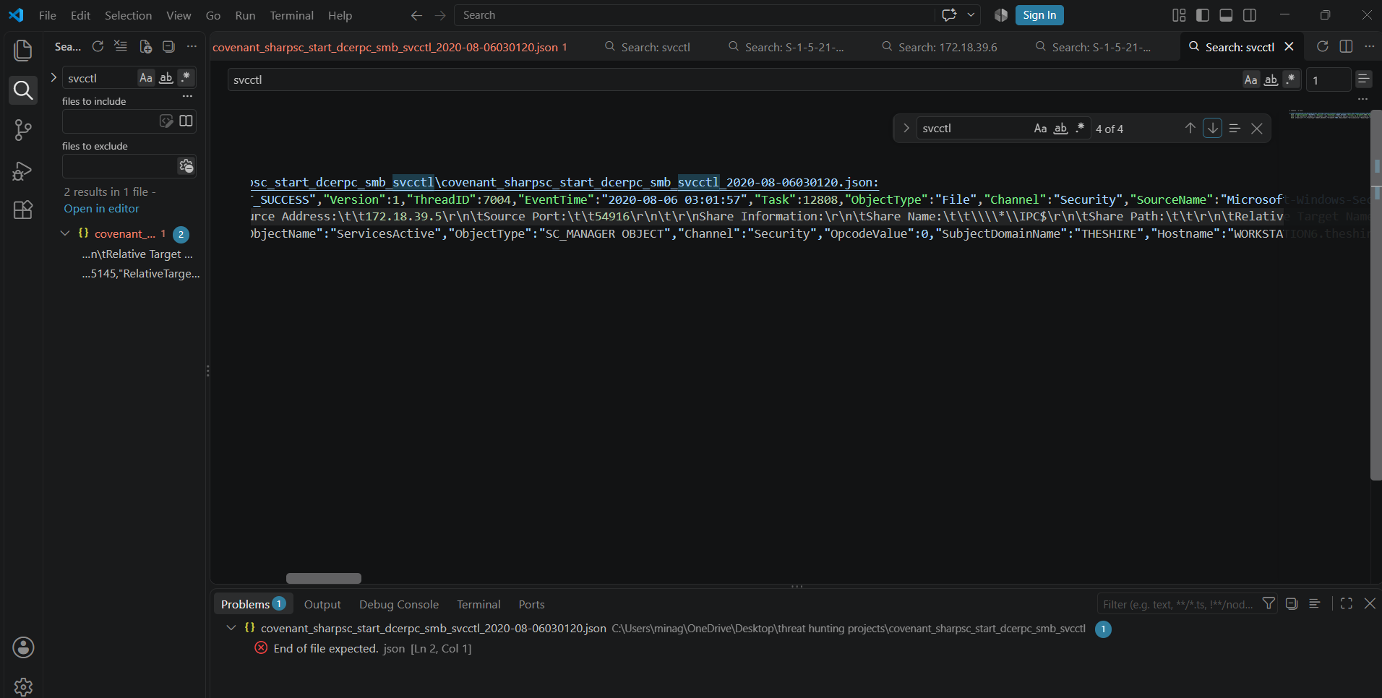

Observed "SubjectUserSid":"S-1-5-21-1363495622-3806888128-621328882-1104","SubjectUserName":"pgustavo","ShareName":\\\\*\\IPC$. Search with user id and observe messages
First message windows filtering platform allowed a connection , source is 172.18.39.5 and destination is 172.18.39.6 and destination port is 445.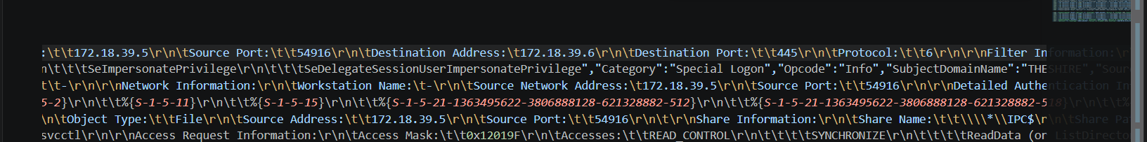

Second message is special privileges are assigned to new logon
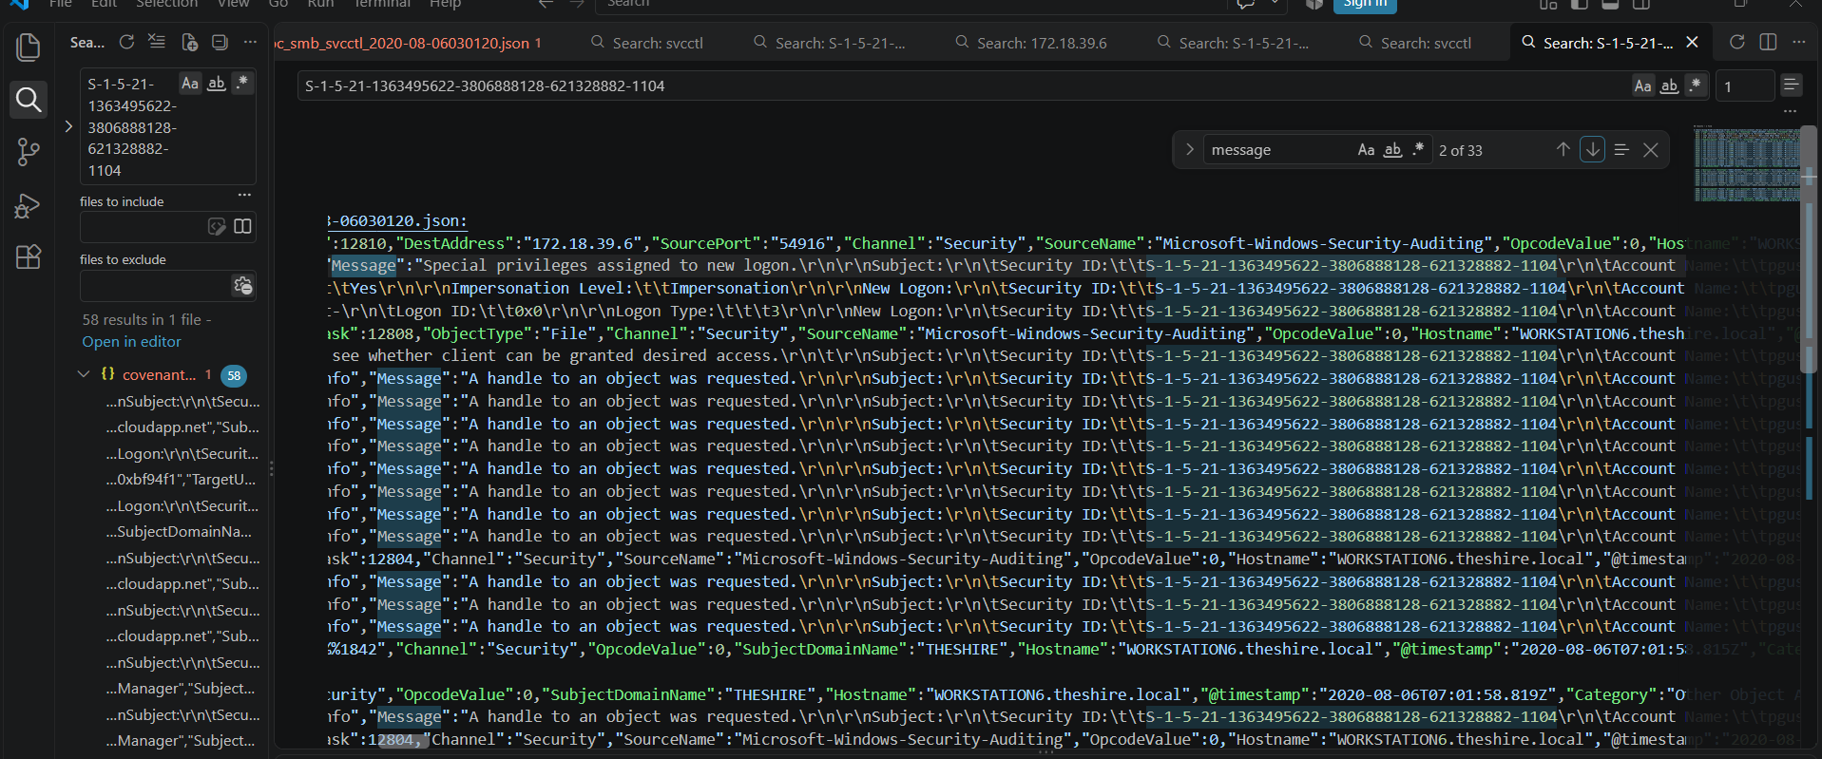

Next message is network share is access
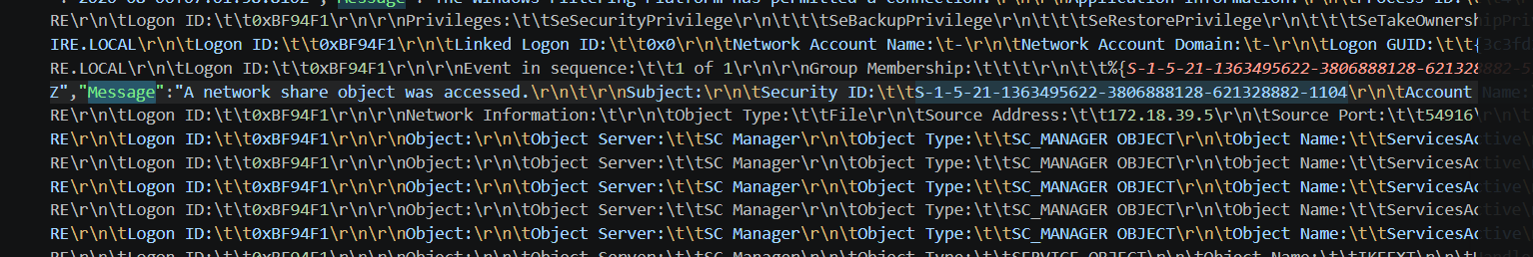

Next message a handle to object is requested and object name is ServicesActive
Next account was successfully logged in
Attempt to duplicate handle observed

Overall activity:

The IPC$ share was accessed by the identified user. Special privileges were assigned to a new logon, after which an account-creation event was observed. A handle was then requested for the ServicesActive object, followed by a successful account logon and an attempt to duplicate a handle.

